**Kubernetes Task-2**

**Task Description:**

Create the K8s EKS, further you have to do the deployment of the Nginx application and access the application outside the cluster.

**Step 1: Launch new Ubuntu VM using AWS Ec2 ( t2.micro)**

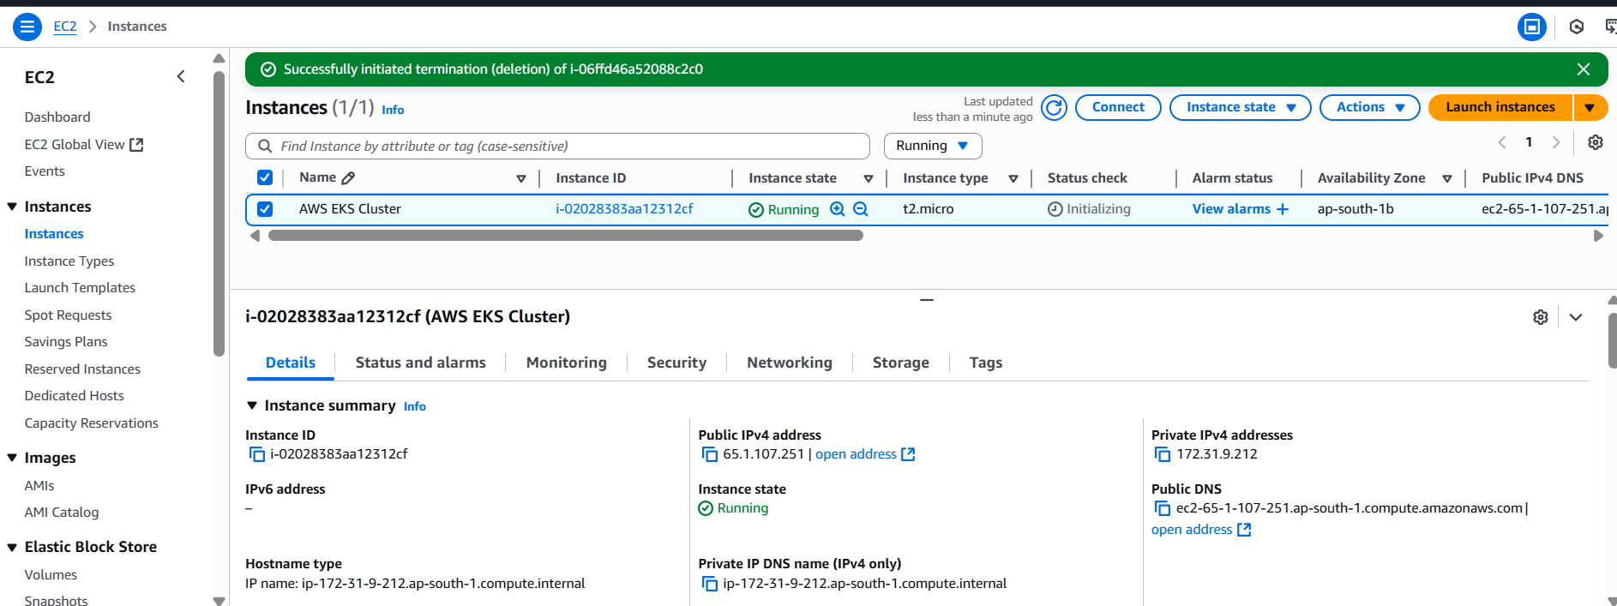

**Step 2:Connect to machine and install kubectl**

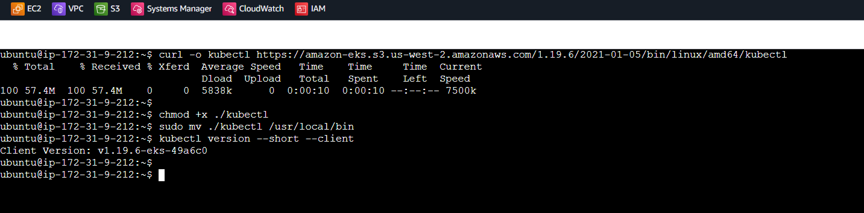

**Step 3:Install AWS CLI latest version**

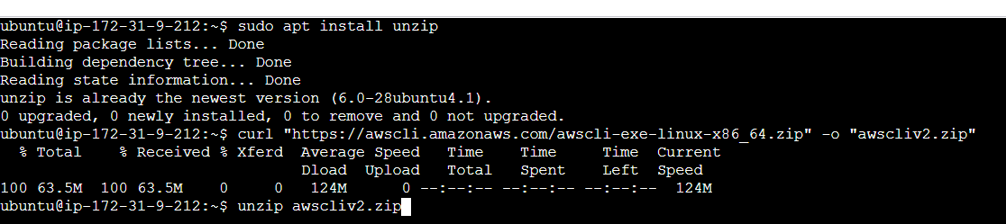

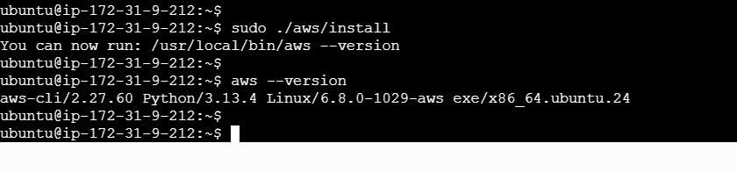

**Step 4:Install eksctl**

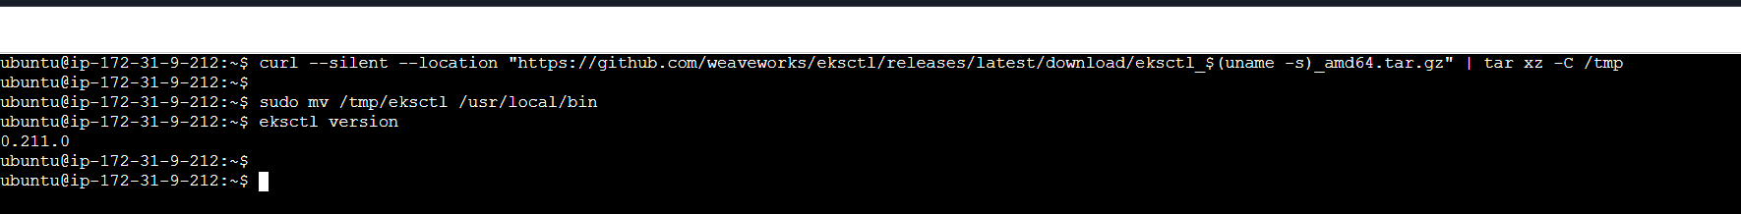

**Step 5 : Create IAM role & attach to EKS**

1. Create New Role using IAM service ( Select Usecase - ec2 )
2. Add below permissions for the role
   * Administrator - acces
3. Enter Role Name
4. Attach created role to EKS Management Host (Select EC2 => Click on Security => Modify IAM Role => attach IAM role we have created)

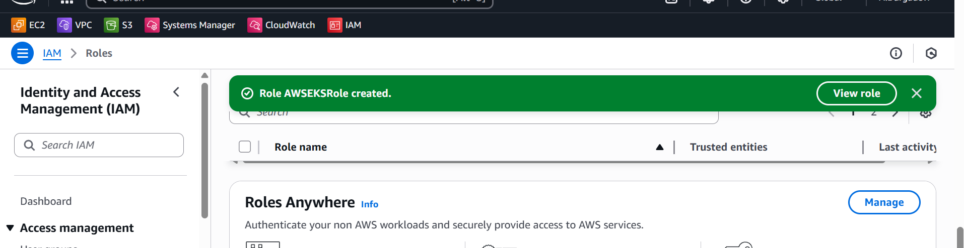

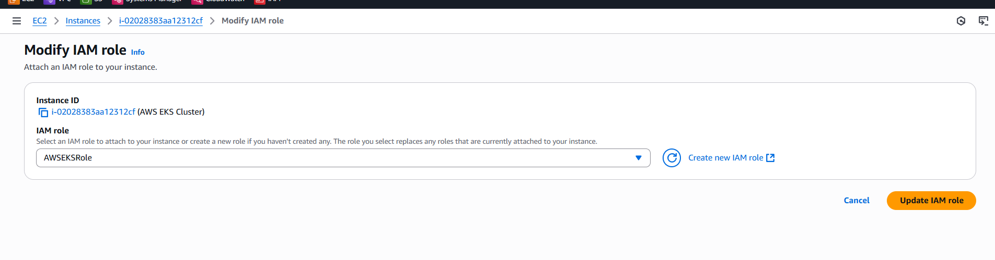

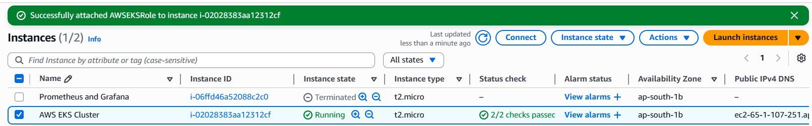

**Step 6: Create EKS Cluster using eksctl**

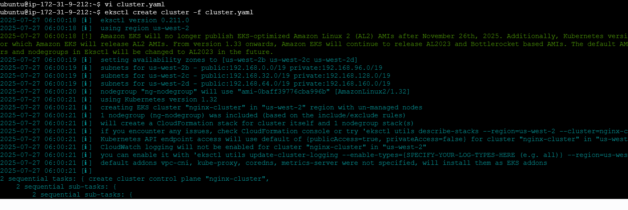

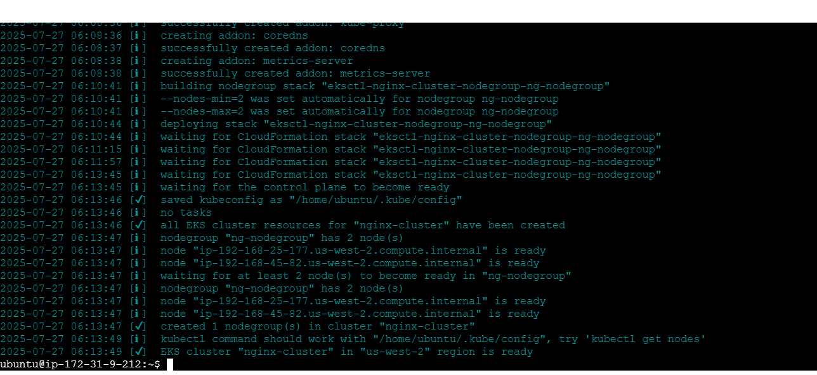

**Configure kubectl to Talk to EKS  
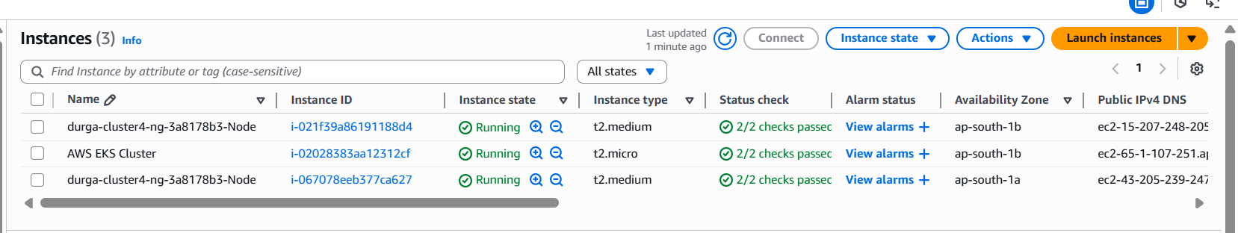**

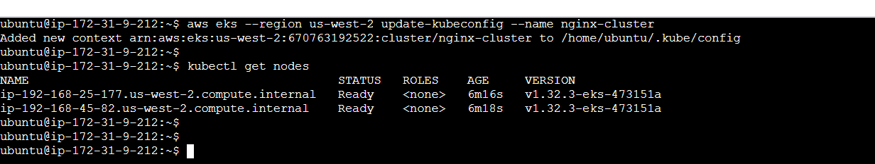

**Step 7: Deploy the NGINX Application**

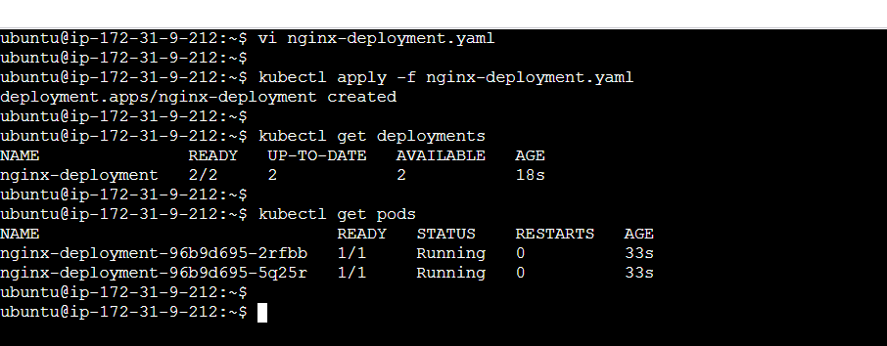

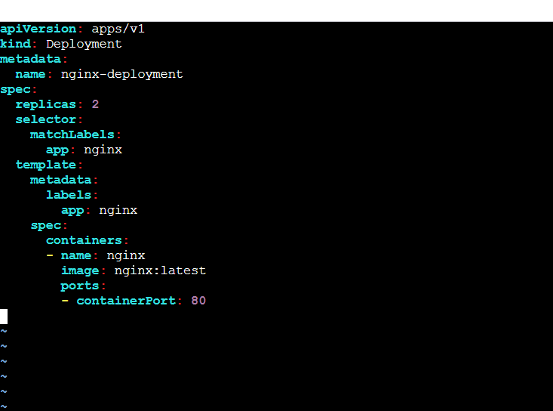

**Step 7: Expose NGINX Using LoadBalancer**

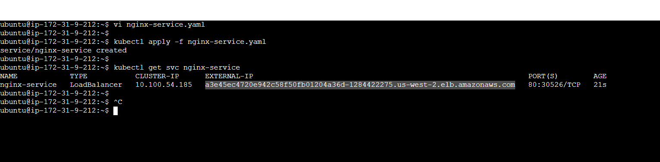

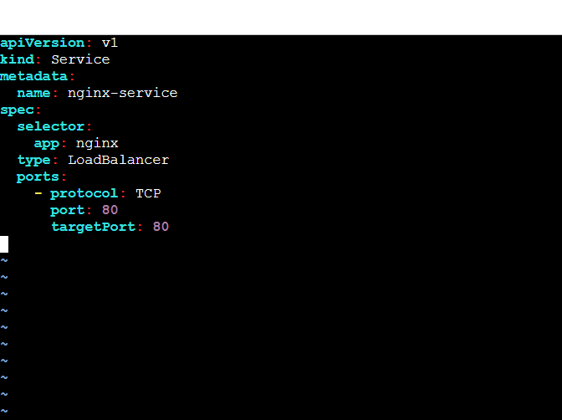

**Step 8: Access the NGINX App  
